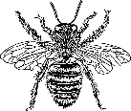
-WALLEYE WEEKEND – KNOWLEDGE QUEST - 2018
Test your bee & Fond du Lac area bee history knowledge
AND get entered for some great prizes.

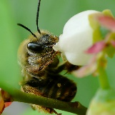
1. According to “Bee Culture” magazine, (June 26, 2017), the two crops that most heavily rely on bees for pollination are? Blueberries and Almonds
*Blueberry acres have jumped from 53,000 to 82,600 (2007-2014)
*Almond acres have jumped from 400,000 to 800,000 (1996 – 2014)

Some of the most important types of native plants used by honey bees in Wisconsin:
Dandelion, clover, basswood, sweet clover, fireweed or Willowherb, buckwheat, goldenrod, Spanish needle, and asters.

2. When was the Wisconsin Beekeepers Association established: 1878
The name officially changed to the Wisconsin Honey Producers Association in 1965.
The East Central Wisconsin Beekeepers Association was established in 2009.

When was the Langstroth hive (the wooden box hives most commonly used by today’s beekeepers because of their movable frames) patented? 1851

What are the old fashioned dome shaped straw hives called? Skeps

In what month is National Honey Month celebrated? September

What is the name of the most detrimental parasite affecting the bee population today?
Varoa Mite.

When was the 58th Annual Wisconsin Beekeepers Association meeting held at the Hotel Retlaw and sponsored by the Rueping Leather Co? October 29 & 30, 1936.

In what year Wisconsin’s Honey Queen (Barbara Bird) welcome President Richard Nixon to the Oshkosh Airport?
1958
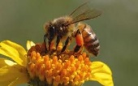
Where is the Honey Acres Honey Museum located? Ashippun, Wisconsin since 1852
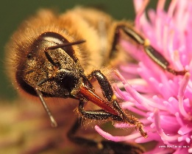
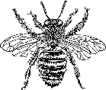
Honey Acres, Inc
PO Box 346
N1557 Highway 67
Ashippun, Wisconsin 53003
Phone: 1-800-558-7745
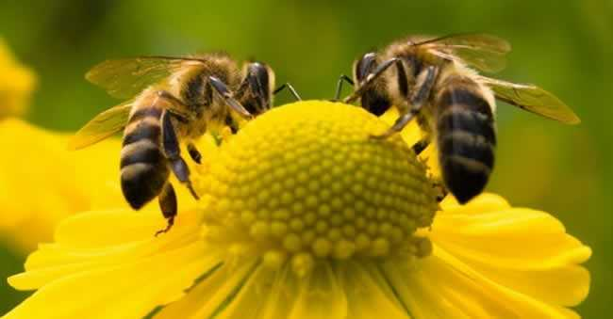
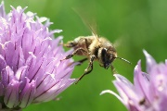
In what year did Fond du Lac adopt the bee ordinance? 2015
And just 4-months later the City chicken ordinance was also adopted.

ASK US ABOUT BEE KEEPING and HONEY PRODUCTION! We are what’s buzzzzing!!!
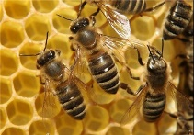
EAST CENTRAL WISCONSIN BEEKEEPERS ASSOCIATION
Visit us at ourbeeblog.blogspot.com

